**Assignment 16.2: A New Concept**

The assets I downloaded are **Creator Kit: RPG** and **Meet and Talk - Dialogue System**. The reason I only downloaded these two assets that they are free to download.

One of the assets I downloaded, **Creator Kit: RPG** is one of the assets are the core asset to for making one of my capstone projects I plan to make; the RPG game. It shows the setup of the 2D RPG game with little text shown below in Picture 16.2-1. Although, I do not have a brand new-build, but the sample graphics are polished, character controls are present, and some text shown as well.

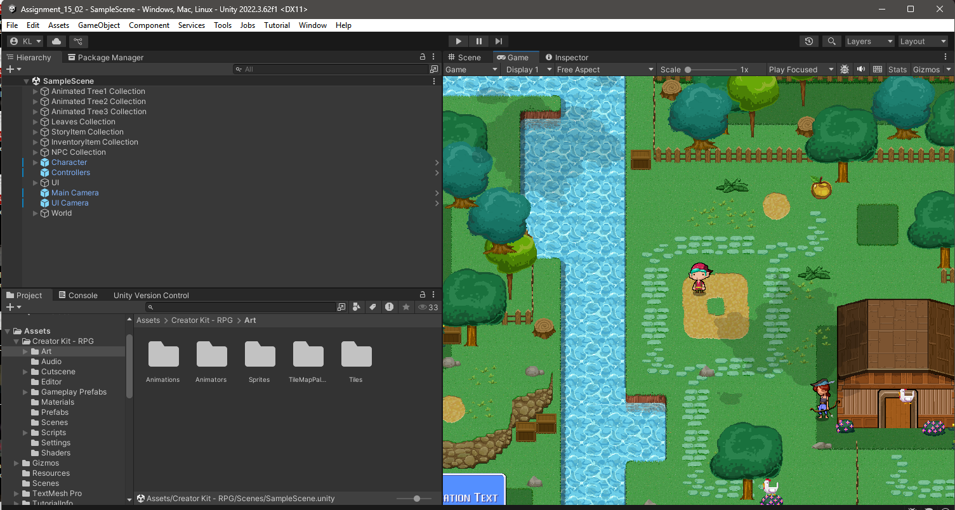

**Picture 16.2-1: The setup picture for capstone RPG game**